AI FAQ ASSISTANT
Description
The AI FAQ Assistant is a robust, secure, and intelligent REST API platform designed to streamline FAQ creation, user authentication, and AI-powered content management. Built with Node.js and Express.js, the application utilizes MongoDB as its primary data store along with Mongoose ODM for elegant data modeling and schema validation.
Security is central to the architecture, implementing JWT (JSON Web Tokens) for stateless user sessions and route guarding alongside bcrypt for strong password encryption. The backend handles intensive operations like automated FAQ generation, semantic search queries, and dynamic context parsing. It also features robust centralized error handling and response status sanitization to prevent unhandled database leakage and ensure operational durability.
Scenario-Based Case Study
Background
Priya is a customer support operations manager who handles massive backlogs of repetitive user inquiries but struggles to organize entries, classify topics, write precise summaries, and track client question trends efficiently.
Problem
- Difficulty generating and maintaining up-to-date documentation workflows.
- Limited visibility into semantic search match keywords and rapid query resolutions.
- Limited visibility into semantic search match keywords and rapid query resolutions.
- Time-consuming manual processes for drafting complex support answers.
- Lack of unified database permission layers protecting private documentation from public adjustments.
Team ID : SWTID-2026-8718
Name | Email Id | NM Id
Reshma M  (leader) | reshusalman23@gmail.com | 6C96DD1EBF5D39FB4E94A2CEF5C24BBC
Nandhini N  (Member) | nandhinislm2006@gmail.com | 10F3DA1C94AF3C8AC97494E328CA76F1
Harini S  (Member) | harinimanjula123@gmail.com | C210644BAA0E0A7BEF44F8A139DB7F2D
Madhumitha R  (Member) | madhumithamadhumitha2776@gmail.com | C2F4996D38FDDF39FAE4B2CEC20401CE

PHASE-1
Software Requirements

- Operating System: Windows 10/11, macOS, or Linux (supports cross-platform operations).
- Node.js (v18 or above): Runtime ecosystem running server logic and routing infrastructure.
- npm (v9 or above): Node package manager to control operational dependencies.
- Express.js (v4/v5 Ecosystem): Lightweight routing web framework to construct backend RESTful entry points.
- MongoDB / Mongoose ODM: Document NoSQL engine storing application users and curated data entities.
- Postman / ThunderClient: API verification toolkit to assert schema validation responses across administrative route shields.
- Code Editor: Visual Studio Code or similar IDE environment.

PHASE-2
Hardware Requirements

- Processor: Intel Core i5 (8th Gen or above) / AMD Ryzen 5 or equivalent.
- RAM: 8 GB minimum (16 GB recommended for concurrent instances of MongoDB processing layers).
- Storage: 1 GB of available disk workspace.
Epic-1: Project Architecture
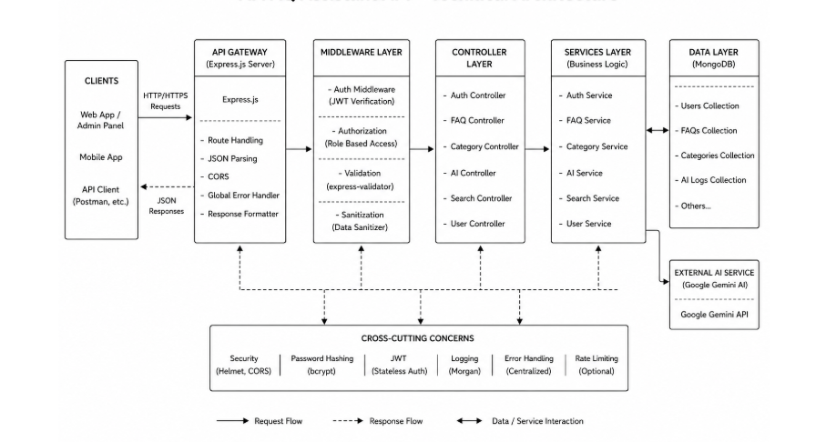
The AI FAQ Assistant application exposes structured endpoints handled by a layered server architecture model. Incoming requests undergo filter processing before interacting with data services.
Components Definition
- Interface: API tools like Postman query distinct route paths to extract JSON entities.

- Express Server Gateway: Monitors network ports, maps explicit HTTP methods (GET, POST, PUT, DELETE), parses incoming JSON payloads, and handles CORS headers.
- Authentication Middleware: Extracts tokens from headers, validates user context signatures, and evaluates authorization thresholds for guarded resource paths.
- Granular Services (Logic Modules): Enforces isolated domain rules for user session life cycles and operational query modifications.
- Database Interface Layer: Mongoose translates operational application logic into performant native MongoDB queries.
- AI Flow (Service Integration): Connected to external AI models via Google Gemini SDK integrations, letting the controller layer offload complex question-answering tasks and automated topic generation workflows.

PHASE-3
Project Setup and Configuration

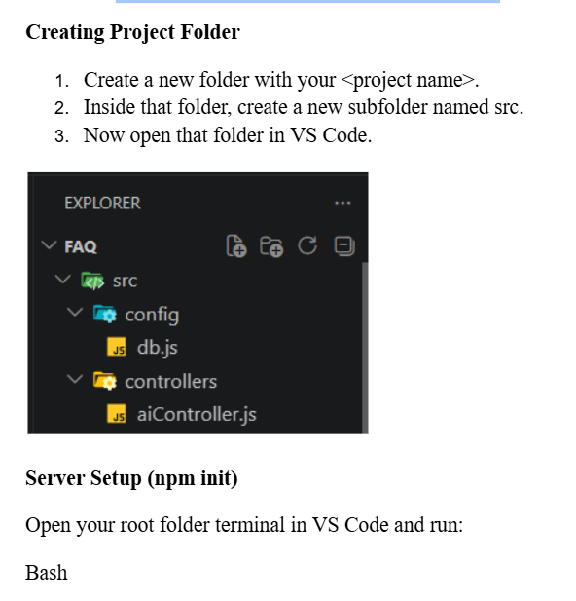
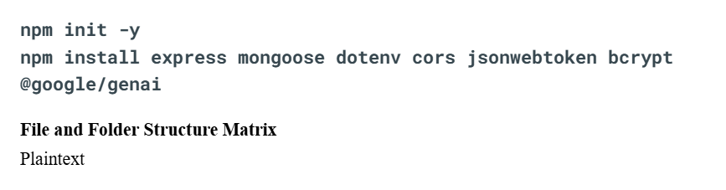

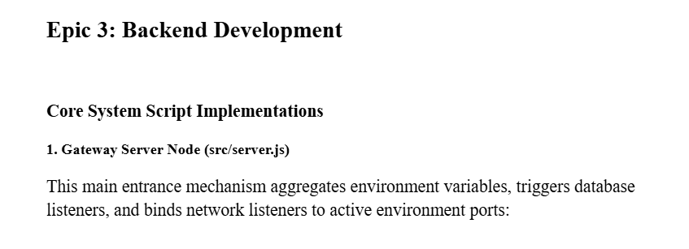

Phase-4
Database Configuration

Mongoose Schema Definitions
1. Identity Resource Document Schema (src/models/User.js)
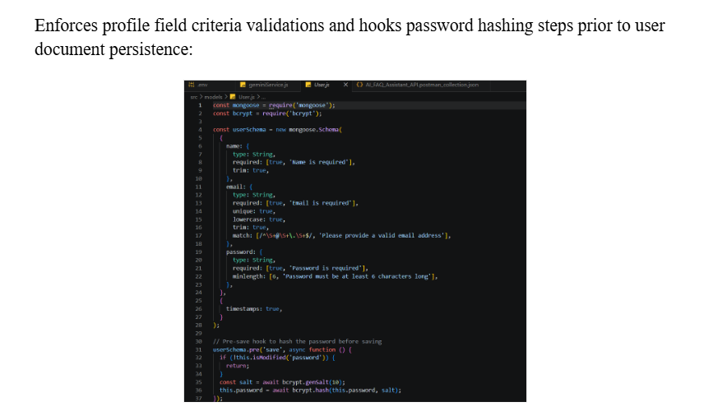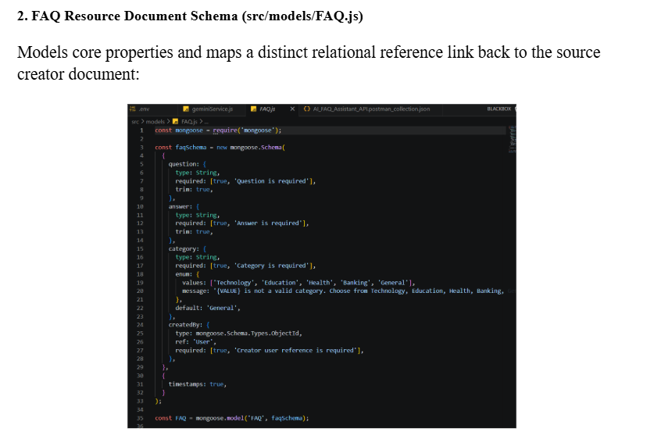

PHASE-5
Project Executions

Running the API Application
- Install Postman or Thunder Client (VS Code extension).
- Start the backend development server environment parameters:
Bash

npm run dev
API Testing Specification Demo
To verify operational structural integrity via execution endpoints, map endpoints using the configurations below:
1. Identity Onboarding Path Registration
- Route: POST /api/auth/register
- Access: Public
- Payload Request Body JSON:
{
“name”:”sk”,
“email”:”sk@gmail.com”,
“password”:”123456789”
}

PHASE-6
API Testing Specification Demo

To verify operational structural integrity via execution endpoints, map endpoints using the configurations below:
1. Identity Onboarding Path Registration
- Route: POST /api/auth/register
- Access: Public
- Payload Request Body JSON:

1.http://localhost:5000/api/auth/register

{
“name”:”Sk”,
“email”:sk@gmail.com,
“password”:”123456789”
}

2.http://localhost:5000/api/auth/login

{
“email”:sk@gmail.com,
“password”:”123456789”
}

PHASE-7
Resource Entity Creation (FAQ)

Route: POST /api/faqs
Access: Private (Bearer <JWT Token>)
Payload Request Body JSON:
{
"question": "How do I configure custom category tags?",
"answer": "Navigate to settings panel, append keyword tags arrays, and save schema.",
"category": "Configuration"
}

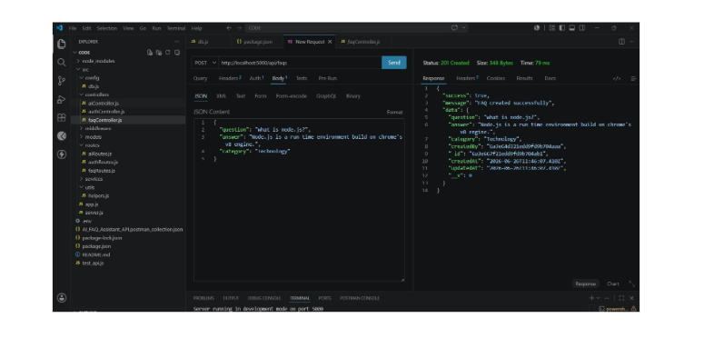

PHASE-8
AI Intelligent Content Automation (Generate FAQ Pair)

AI Intelligent Content Automation (Generate FAQ Pair
- Route: POST /api/ai/generate-faq
- Access: Private (Bearer <JWT Token>)
- Payload Request Body JSON:

{
"topic": "Mongoose schema indexing validation runtime workflow optimization"
}

